Grade One School Supply List 2023-24
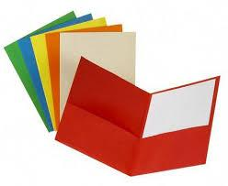3 2 sided folders. If possible please get the following colours ( red, yellow, orange)- no prongs please!
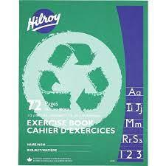Need Two (2) Green Hilroy ½ Lined and ½ Plain Notebooks
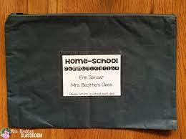 One (1) Message Bag * Can get at Dollar Store.*
1 pair of scissors
2 packages sharpened Pencils and sharpener
4 pack of whiteboard markers and eraser/old mitt or old sock to use as an eraser
4 glue sticks *We use a lot of glue*
2 packages of 24 pack of Crayons
2 Black Sharpie Markers
1 package of coloured pencils
1 package of Markers
4 white erasers
1 four (4) pack of Scribblers
1 Tool Box to house school supplies
1 personal size whiteboard (Approx. 9” x 12” size)
Luggage Tag with bus number for dismissal
Indoor sneakers

Not required but appreciated…large freezer bags, baby wipes and post-it notes
