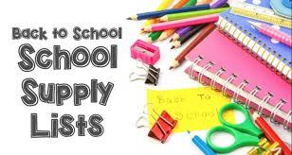 Grade Two School Supply List 2023-24
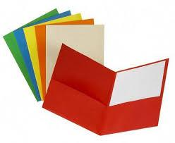
Four 2-sided pocket folders. If possible please get the following colours (red, yellow, green, blue)- no prongs please!
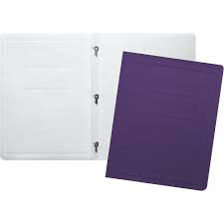 Two 3-pronged Duotangs. If possible please get the following colours (yellow, green)
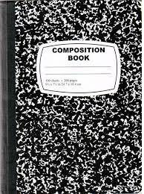 1 composition notebook. *Can get at Dollar Store.*
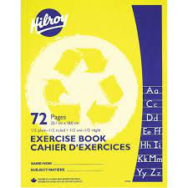 1 Plain Notebook (blue) and 1 half lined/half plain Notebook (yellow)
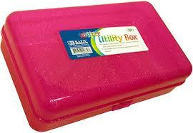 1 Tool Box to house school supplies
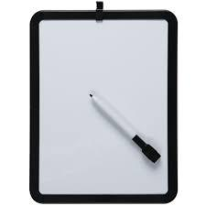1 whiteboard (Approx. 9” x 12” size)
1 pair of scissors
2 packages sharpened Pencils and sharpener
4 pack of whiteboard markers and eraser/old mitt or old sock to use as an eraser
4 large glue sticks *We use a lot of glue*
1 package of 24 pack of Crayons
1 package of Colored Pencils *Please ensure pencils are sharpened*
2 Black Sharpie Markers
1 package of Markers
1 package of Scribblers
4 white erasers
Indoor sneakers
*Not required but appreciated…Large Ziploc freezer bags
and unscented baby wipes*

